**ORDER FOOD ONLINE ON ZOMATO**

**Dissertation submitted in partial fulfillment of the**

**requirements for the award of the Course of**

**EXL- Certified Software Test Engineer**

**Submitted By**

**Rijwana S.**

**BATCH : 2022 – 7607**

**ENROLLMENT NUMBER : EBEON0722634378**

**Under the Guidance of**

**MOHANA PRIYA Trainer**



|  |  |
| --- | --- |
| S.NO | INDEX |
| **1** | INTRODUCTION |
| **2** | OBJECTIVE OF SYSTEM |
| **3** | SYSTEM SPECIFICATION |
| **4** | IMPLEMENTION |
| **5** | SYSTEM CODING |
| **6** | SYSTEM OUTPUT |
| **7** | SYSTEM TESTING |

#### 1:INTRODUCTION

##### 1.1:Project Outline ( Purpose And Goal )

##### **Zomato** is an [Indian](https://en.wikipedia.org/wiki/India) restaurant search and discovery online service (web and app). It is spread worldwide, And is known for its Online food delivery It has also launched Cloud kitchens in many regions across the world, It gathers and provides information of restaurants on a regular basis, it allows food lovers to share their reviews and photos of every restaurant. so that people can make an informed choice.

##### Zomato is one of the most comprehensive and user-friendly apps where people can search for nearby restaurants and cafés, order food online, and get it delivered at their doorstep in no time. Moreover, you can also get accurate information about restaurants as it provides menus, reviews, and ratings. Based on that, users can place orders and enjoy lip-smacking food at their homes.

Every meal matters. Every meal matters. In the summer of 2015, when we were preparing to

launch online food ordering services in India, we had more questions than answers.

Customers use our platform to search and discover restaurants, read and write customer

generated reviews and view and upload photos, order food delivery, book a table and make

payments while dining-out at restaurants.

**2.OBJECTIVE OF SYSTEM**

**2.1:OBJECTIVE OF SYSTEM**

The Indian internet and e-commerce sector has emerged to be one of the fastest growing sectors of the country, even in the pandemic-hit economy. The Indian start-up ecosystem witnessed 43 companies turn unicorns in 2021; more than 30 odd unicorns that were created till date up to 2020.

Zomato offered a solution by being the bridge between the needs of the consumer and offering scalability/distribution to manufacturers (restaurants).  
  
As we all understand, the gross margins (ex-RM cost) are very high (around 65%-75%) in the food business, but the fixed overhead cost for the restaurant owners also remains heavy. Therefore, for every incremental revenue if the restaurant has to share a certain percentage (15%-25%) with the distribution partner like Zomatoo.

Online restaurant guide and food ordering firm Zomato Monday said it is planning to convert 40 per cent of its delivery fleet into power-assisted bikes in two years.

Currently, the company has over 5,000 cyclists operating across 12 cities in India, with the majority of the fleet being in Delhi-NCR, Zomato said in a statement.

The company provides food delivery services in 150 cities across the country with a last-mile delivery fleet of 1.5 lakh partners, it added.

"We are working closely with our vendor partners to raise the scale of e-cycle adoption and aim to convert 40 per cent of our fleet to power-assisted bikes within the next two years," Zomato Food Delivery business CEO Mohit Gupta said.

# **3.** **SYSTEM SPECIFICATION**

**3.1:HARDWARE SPECIFICATION**

Processors will continue to get faster, smaller and cheaper, whereas memory will continue to get faster, larger and cheaper. The trend except to have a reasonable memory to a powerful processor.

Processor : 11th Gen Intel(R) Core(TM) i3

Ram : 1GB RAM

Hard Drive : 160 GB

Monitor : 16 INCHES

Keyboard : 104 keys

Mouse : Logitech Optical Mouse

##### 3.2:SOFTWARE SPECIFICATION

When an application project is considered the three basic software requirements are the platform in which the project is developed, the front-end tool that provides the interaction with the users and the back- end tool that stores the data.

Operating System : Windows11

Front-end : Visual Studio, Microsft Edge.

##### 3.3:FEATURES OF LEARNING IN ONLINE SYSTEM

1. Vast choices of Restaurants
2. Order Scheduling
3. Geo-location
4. Rating System
5. Internal Payment System

## **4.IMPLEMNETION**

#### 4.1:MODULES

In this website I have created the online food deliver to customer. And that is name is Zomato Online Food.

In website I have to include home, about us, course etc….

Home

Contanct Us

Delivery

Location

Self pickup

Paymanet mode

Zomato member

Check prices.

#### 4.2:(FRONTEND) WEBPAGE

I have used HTML , CSS , JAVASCRIPT to develop the frontend design

##### 4.3:HTML

(Hypertext Markup Language)

HTML stands for HyperText Markup Language. It is used to design web pages using a markup language. HTML is the combination of Hypertext and Markup language.

Hypertext defines the link between web pages. A markup language is used to define the text document within the tag which defines the structure of web pages.

This language is used to annotate (make notes for the computer) text so that a machine can understand it and manipulate text accordingly.

Most markup languages (e.g. HTML) are human-readable. The language uses tags to define what manipulation has to be done on the text.

##### 4.3:HTML page structure:

The basic structure of an HTML page is laid out below. It contains the essential building-block elements (i.e. doctype declaration, HTML, head, title, and body elements) upon which all web pages are created

##### 4.4:CSS

##### ( Cascading Style Sheet )

**C**ascading **S**tyle **S**heets, fondly referred to as **CSS**, is a simply designed language intended to simplify the process of making web pages presentable.

CSS allows you to apply styles to web pages. More importantly, CSS enables you to do this independent of the HTML that makes up each web page.

It describes how a webpage should look: it prescribes colors, fonts, spacing, and much more. In short, you can make your website look however you want.

CSS lets developers and designers define how it behaves, including how elements are positioned in the browser.

While html uses tags, css uses rulesets. CSS is easy to learn and understand, but it provides powerful control over the presentation of an HTML document.

* + **CSS saves time:** You can write CSS once and reuse the same sheet in multiple HTML pages.
  + **Easy Maintenance:** To make a global change simply

change the style, and all elements in all the webpages will be updated automatically.

* + Search Engines:CSS is considered a clean coding technique, which means search engines won’t have to struggle to “read” its content.
  + Superior styles to HTML:CSS has a much wider array of attributes than HTML, so you can give a far better look to

your HTML page in comparison to HTML attributes.

* + Offline Browsing:CSS can store web applications locally with the help of an offline cache. Using this we can view

offline websites.

##### 4.5:JAVASCRIPT

JavaScriptis a lightweight, cross-platform, and interpreted compiled programming language which is also known as the scripting language for webpages.

It is well-known for the development of web pages, many non-

browser environments also use it.

JavaScript can be used for CLIENT-SIDE developments as well as SERVER_SIDE developments.

Javascript is both imperative and declarative type of language. JavaScript contains

a standard library of objects, like array, date and math, and a core set of language

elements like operators, control structures, and statements.

AngularJS is a JavaScript framework. It can be added to an HTML page with a <script> tag.

AngularJS extends HTML attributes with Directives, and binds data to HTML with Expressions.

AngularJS is a JavaScript Framework

AngularJS is a JavaScript framework written in JavaScript.

AngularJS is distributed as a JavaScript file, and can be added to a web page with a script tag:

<script src="https://ajax.googleapis.com/ajax/libs/angularjs/1.6.9/angu lar.min.js"></script>

AngularJS is a JavaScript framework. It can be added to an HTML page with a <script> tag.

AngularJS extends HTML attributes with Directives, and binds data to HTML with Expressions.

AngularJS Extends HTML

AngularJS extends HTML with ng-directives.

The ng-app directive defines an AngularJS application.

The ng-model directive binds the value of HTML controls (input, select, textarea) to application data.

**5.SYSTEM CODING:-**

**5.1:Syntax:**

<!DOCTYPE html>

<html>

<head>

<meta name="viewport" content="width=device-width, initial-scale=1">

<meta name="viewport" content="width=device-width,intial-scale=1:0">

<link rel="stylesheet" href="s.css">

<link rel="stylesheet" href="https://unpkg.com/swiper@7/swiper-bundle.min.css" />

<style>

div.scrollmenu {

background-color: #333;

overflow: auto;

white-space: nowrap;

}

div.scrollmenu a {

display: inline-block;

color: white;

text-align: center;

padding: 14px;

text-decoration: none;

font-family: cursive;

}

div.scrollmenu a:hover {

background-color: #777;

}

</style>

<style>

h1 {

background-color: yellow;

text-align: center;

font-size: 50;

}

</style>

<style>

img {

border-radius: 10px;

}

</style>

<style>

body {

background-image: url("z2.jpg");

}

</style>

<style>

.swiper{

width: 70%;

height: fit-content;

}

.swiper-slide img{

width: 70%;

padding-top: 30px;

padding-right: 150px;

padding-bottom: 50px;

padding-left: 80px;

}

.swiper .swiper-button-prev, .swiper .swiper-button-next{

color: #fff;

}

.swiper .swiper-pagination-bullet-active{

background: #fff;

}

</style>

<style>

a{

color:red;

font-size: large;

font-size: 150%;

</style>

<style>

span {

background-color: #0AFFFF;

}

</style>

</head>

<body>

<h1 style="color: deeppink">Order food Online On Zomato</h1>

<img src="z1.jpg" alt="i" width="150" height="150">

<div class="scrollmenu">

<a href="#home">Home</a>

<a href="#news">Delivery</a>

<a href="#contact">Contact us</a>

<a href="#about">self pick up</a>

<a href="#support">zomato disc.</a>

<a href="#blog">night life</a>

<a href="#tools">location</a>

<a href="#base">payment mode</a>

<a href="#custom">zomato membership</a>

<a href="#more">log in</a>

<a href="#logo">blogs</a>

<a href="#friends">rating</a>

<a href="#partners">dinning out</a>

<a href="#people">Review</a>

<a href="#Map">Map</a>

</div><br><br>

<div class="swiper">

<!-- Additional required wrapper -->

<div class="swiper-wrapper">

<div

class="swiper-slide">

<img src="C:\Users\Rijwana\OneDrive\Documents\zomato\i1.jpg">

</div>

<div

class="swiper-slide">

<img src="C:\Users\Rijwana\OneDrive\Documents\zomato\b.jpg">

</div>

<div

class="swiper-slide">

<img src="C:\Users\Rijwana\OneDrive\Documents\zomato\d2.jpg"></div>

<div

class="swiper-slide">

<img src="C:\Users\Rijwana\OneDrive\Documents\zomato\e5.jpg"></div>

<div

class="swiper-slide">

<img src="C:\Users\Rijwana\OneDrive\Documents\zomato\j2.jpg"></div>

</div>

<!-- If we need pagination -->

<div class="swiper-pagination"></div>

<!-- If we need navigation buttons -->

<div class="swiper-button-prev"></div>

<div class="swiper-button-next"></div>

</div>

</div>

<script src="https://unpkg.com/swiper@7/swiper-bundle.min.js"></script>

<script>

const swiper = new Swiper('.swiper', {

autoplay: {

delay: 3000,

dsiplayOnInteraction: false,

},

loop: true,

pagination: {

el: '.swiper-pagination',

clickable: true,

},

navigation: {

nextEl: '.swiper-button-next',

prevEl: '.swiper-button-prev',

},

});

</script>

<h2 style="color: red;"><span><a href="t.html">Check Prices</a></span></h2>

<h3 style="color:lime;"><span><a href="l.html">Zomato

Contact us </a></span></h3>

<script src="https://ajax.googleapis.com/ajax/libs/angularjs/1.6.9/

angular.min.js"></script>

<scriptsrc="https://ajax.googleapis.com/ajax/libs/angularjs/1.6.9

/angular-animate.js"></script>

<body ng-app="ngAnimate">

<h1 style="color:palevioletred">Give Review on Yes then

click on it: <input type="checkbox" ng-model="myCheck"></h1>

<div ng-hide="myCheck">

<h1 style="color: blue;">Save it-Yes</h1></div>

</body>

</HTML>

## **6.SYSTEM OUTPUT**

**6.1:Output in the From of Figure:-**

**6.2:HOME Page**

In my online ordering food I have created lots of pages like home,

Delivery, contact us etc.

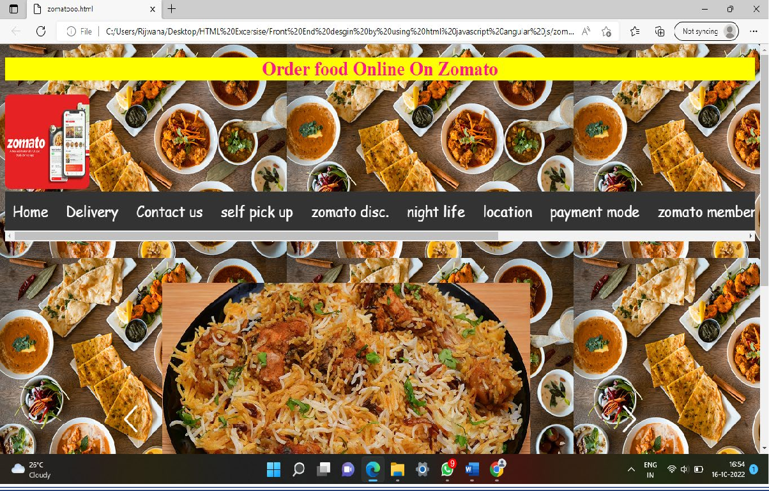

**Figure(1)**

**6.3.Check price for dishes :-**

I have created one another Module that is dishes name and their

prices for dishes.

Whatever you want a dish you check the price and give it.



**Figure(2)**

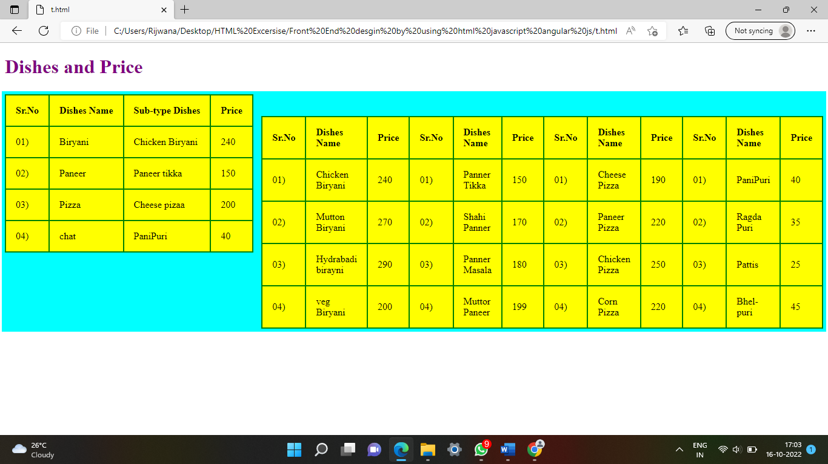

**Figure(3)**

**6.4:Give review**

I have created one another module that is Give review on App.

you just click the given checkbox and then its automatiucally send to

give fededback as rating wise.

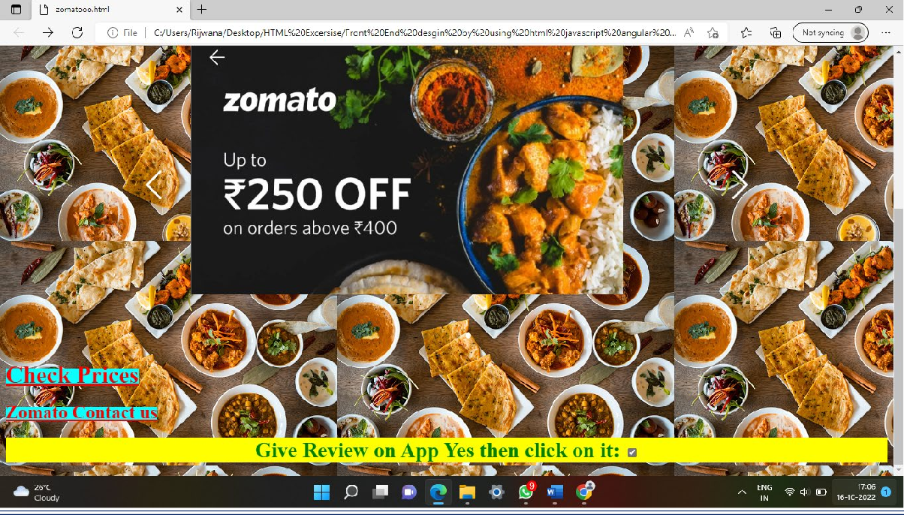

**Figure(4)**

**7.5.Zomato contact Us page:**

I have Created one another module like Zomato Contact us Page.

In this Page I have created all customer details information like

Names,Conatact Num,Pin,Address etc….

If the customer has any problems then,we will slove it through.

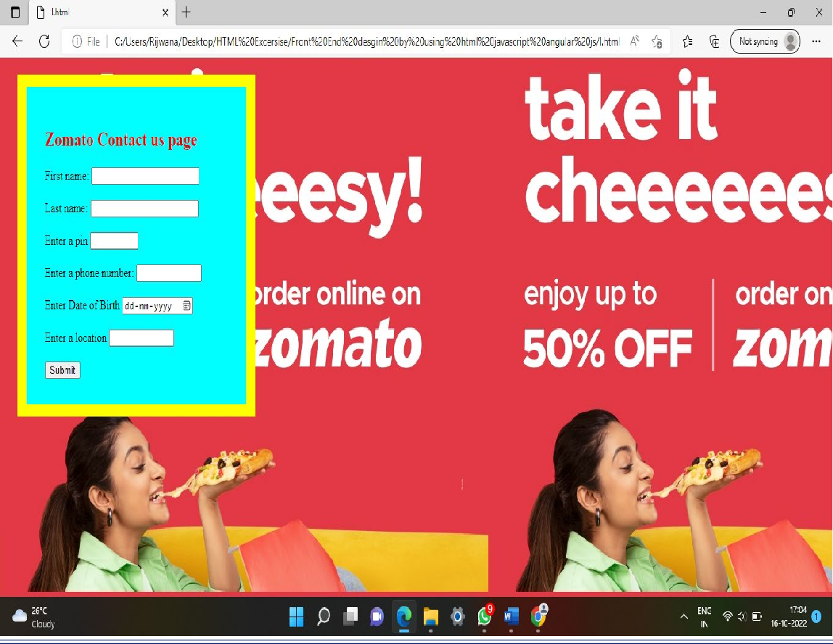

**Figure(5)**

**7.SYSTEM TESTING:**

**7.1:Type Of testing:-**

**7.1.1Unit testing:-**

A unit test is a way of testing a unit - the smallest piece of code that can be logically isolated in a system. In most programming languages, that is a function, a subroutine, a method or property. The isolated part of the definition is important.

**7.1.2.Integration Testing**

Integration testing is the testing when two or more modules are integrated or merged to test if the product works fine. Modules are integrated in a planned manner as per the integration plan.

**Approaches used in Integration Testing are:**

1. Top-Down approach  
2. Bottom-up approach  
3. Mixed approach  
4. Big Bang approach

**Top-down approach**

In Top-down integration testing, the top-level module is developed and tested first. After that immediate sub-modules are integrated with the top-level module and are tested. Stubs are required to complete the integration testing with a top-level module in case the module to be integrated is not developed and tested.

[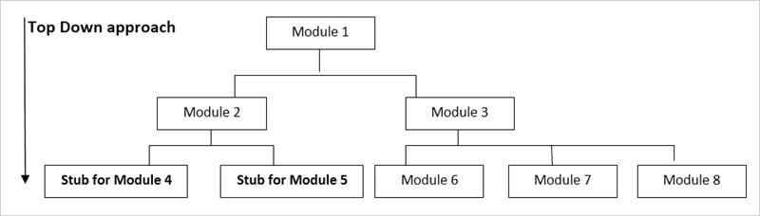](https://www.softwaretestinghelp.com/wp-content/qa/uploads/2018/06/testingmethodologies5.jpg)

To test module 2 in integration testing when modules 4 & 5 are not developed, stubs are created to test the same in the top-down approach.

**Bottom-up Approach**

In the bottom-up approach, sub-modules are developed and tested first and the whole system is tested.

[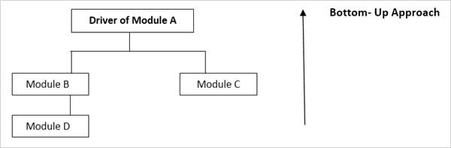](https://www.softwaretestinghelp.com/wp-content/qa/uploads/2018/06/testingmethodologies6.jpg)

To test Module C, the Driver of module A is created so that function can be called.

**Mixed Approach**

The mixed approach is a **combination of both top-down and bottom-up** approaches. In the top-down approach, testing can start only when the top modules are developed and the unit tested.

Same way, bottom-up approach testing, can start only when the modules at the bottom have been developed and tested. The mixed approach overcomes this shortcoming as in the mixed approach, testing can start anytime once the modules are developed.

**Big Bang Approach**

In the Big bang **approach, all the modules are integrated** into one go and are tested. A drawback of this method is that if any error is detected while testing, it would be difficult to find the error-causing module. Once the defect cause is detected, it will be fixed but it would cost high & will be time-consuming as the defect found is at a later stage.

[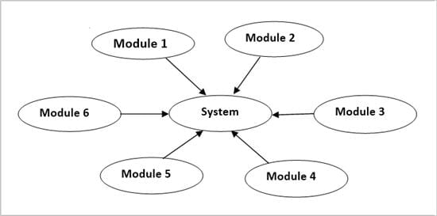](https://www.softwaretestinghelp.com/wp-content/qa/uploads/2018/06/testingmethodologies7.jpg)

#### 7.1.3.System Testing

In system testing, a system as a whole i.e. a completely developed system is tested to find defects. All the modules are integrated to test as a complete system. Scenarios prepared for system testing are run to find the defects.

All the modules of a product are integrated and tested to verify that the built product is as per the customer requirement. End-to-end testing is performed to cover the complete scenarios.

[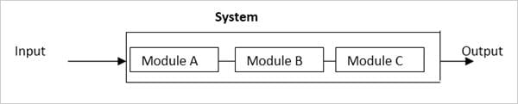](https://www.softwaretestinghelp.com/wp-content/qa/uploads/2018/06/testingmethodologies8.jpg)

#### 7.1.4.Acceptance Testing

Once the System testing is complete, the Product is ready to be released to the Production environment. But before deployment, the customer’s acceptance and approval are required. The customer verifies whether the product is all that they wanted or not. For this acceptance testing is done.

**Types of Acceptance Testing:**

**Alpha Testing:** Alpha testing is done internally by the members of the company who developed the product. This testing is not performed by the developers and testers who developed and tested the product.

**Beta Testing:**Beta testing is done by the actual users in the Production environment. Beta version of the application is released in the real environment to get feedback from the users which indeed helps to reduce the chances of failure of the product in the production environment.

**User Acceptance Testing:**Testing is done at the user end wherein the prepared UAT test cases are executed. Replica of the production environment is created for the customer to perform the user acceptance testing.

**7.1.5.Non-functional testing**

Non-functional testing is done to verify the non-functional aspects of a product. **E.g.** Performance of any product comes under non-functional activity.

Non-functional testing is as important as functional testing is. If it is not done properly, it can lead to major issues in the Product.

**Example:** If Performance testing is not done for new functionality added to the application, when the application goes live it becomes too slow to work with and the customer gets affected with the same.

**Types of Non-functional Testing**

* Performance Testing
* Load Testing
* Stress Testing
* Volume Testing
* Security Testing
* Usability Testing
* Compatibility Testing
* Installation Testing
* Uninstallation Testing
* Recovery Testing
* Documentation Testing

**7.1:Use case diagram:-**

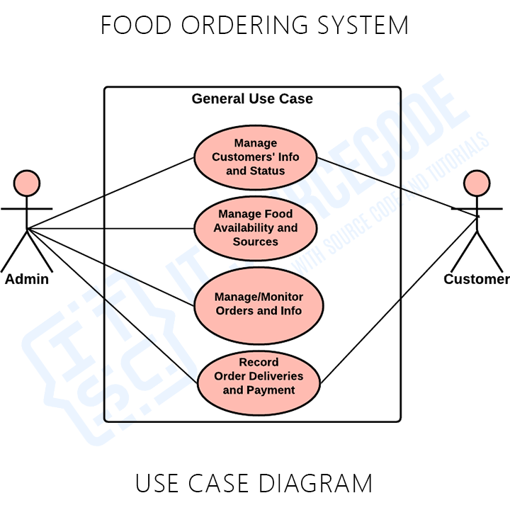

**7.2.1:Activity Daigram:-**

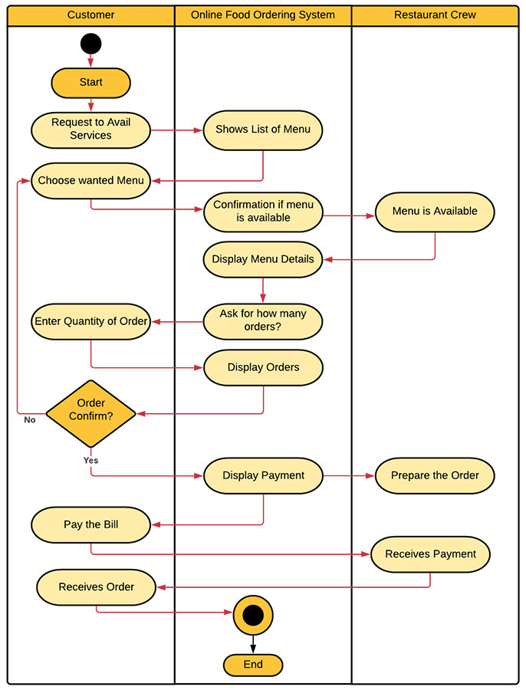

**7.2.3:Class Daigram:-**

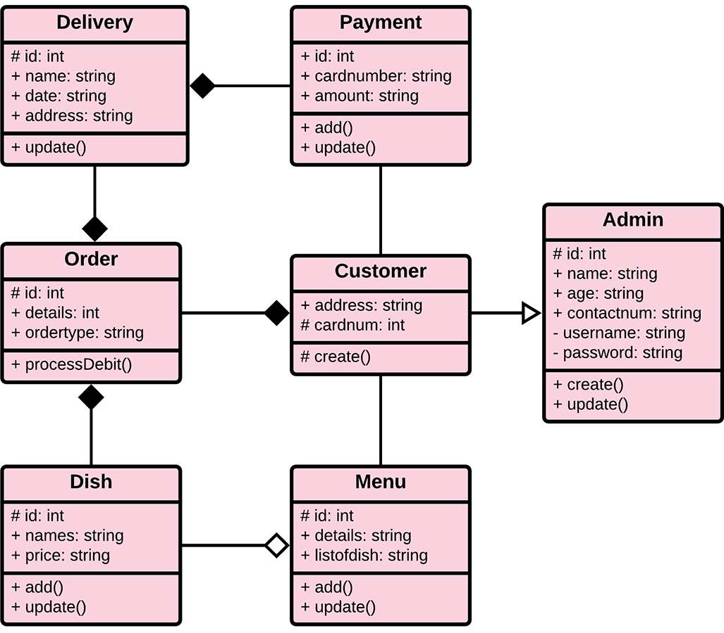

**7.2.4:-ER-daigram**

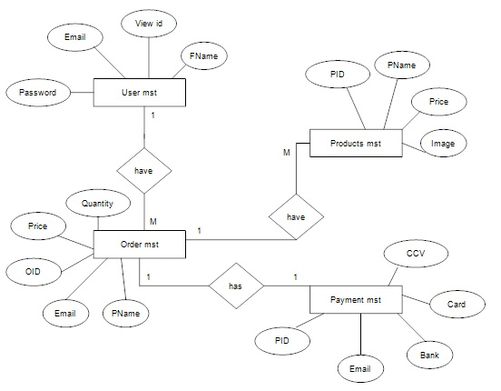

**7.2.5:Data Level flow diagram:-**

**Level 0:-**

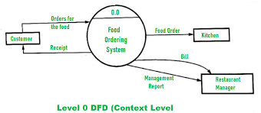

**Level 1:-**

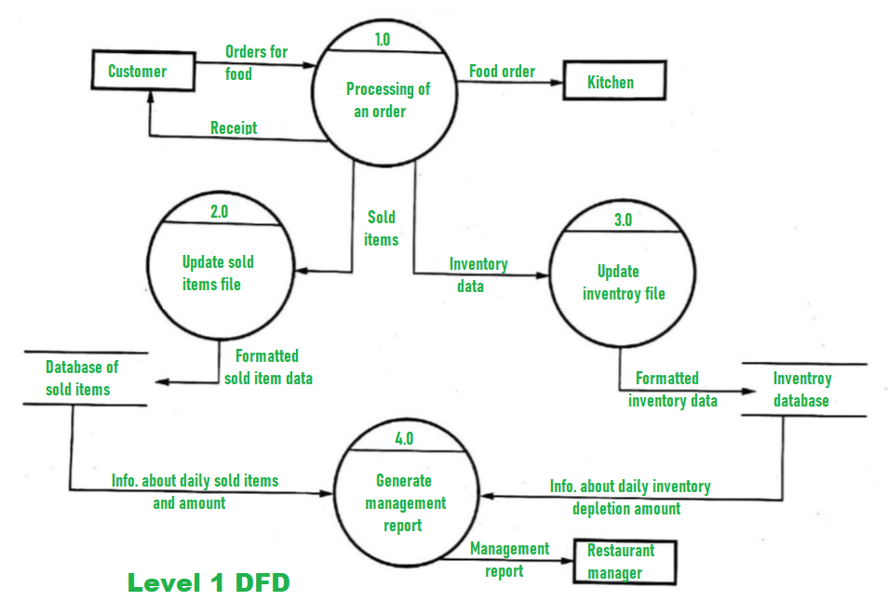

**Level 2**

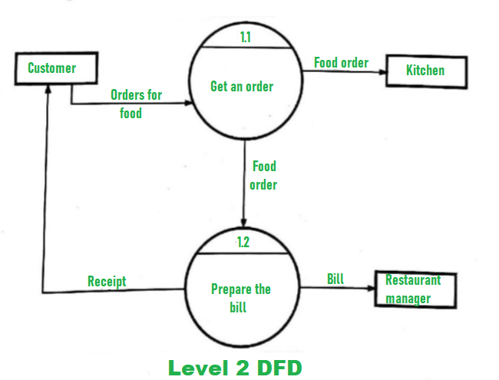

**7.3:Equivalnce partition:-**

**Equivalence Partitioning** or Equivalence Class Partitioning is type of black box testing technique which can be applied to all levels of [software testing](https://www.guru99.com/software-testing.html) like unit, integration, system, etc. In this technique, input data units are divided into equivalent partitions that can be used to derive test cases which reduces time required for testing because of small number of test cases.

* It divides the input data of software into different equivalence data classes.
* You can apply this technique, where there is a range in the input field.

### Example 1: Equivalence and Boundary Value

* Let’s consider the behavior of Order Pizza Text Box Below
* Pizza values 1 to 10 is considered valid. A success message is shown.
* While value 11 to 99 are considered invalid for order and an error message will appear, **“Only 10 Pizza can be ordered”**

**Order Pizza:**

**Here is the test condition**

1. Any Number greater than 10 entered in the Order Pizza field(let say 11) is considered invalid.
2. Any Number less than 1 that is 0 or below, then it is considered invalid.
3. Numbers 1 to 10 are considered valid
4. Any 3 Digit Number say -100 is invalid.

We cannot test all the possible values because if done, the number of test cases will be more than 100. To address this problem, we use equivalence partitioning hypothesis where we divide the possible values of tickets into groups or sets as shown below where the system behavior can be considered the same.

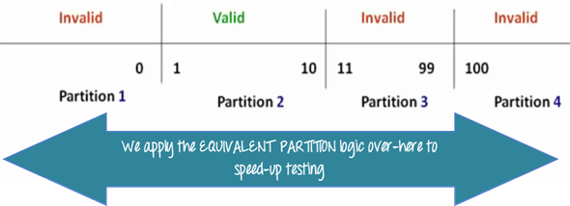

The divided sets are called Equivalence Partitions or Equivalence Classes. Then we pick only one value from each partition for testing. The hypothesis behind this technique is **that if one condition/value in a partition passes all others will also pass**. Likewise**, if one condition in a partition fails, all other conditions in that partition will fail**.

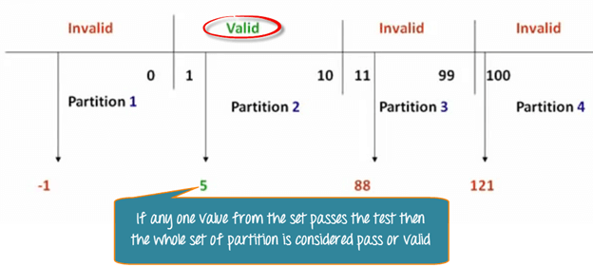

**Boundary Value Analysis**– in Boundary Value Analysis, you test boundaries between equivalence partitions

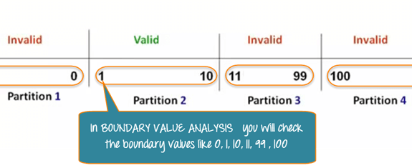

In our earlier equivalence partitioning example, instead of checking one value for each partition, you will check the values at the partitions like 0, 1, 10, 11 and so on. As you may observe, you test values at**both valid and invalid boundaries**. Boundary Value Analysis is also called**range checking**.

Equivalence partitioning and boundary value analysis(BVA) are closely related and can be used together at all levels of testing.

**7.4:Test case report**

**Test case for Order Online food**

**Project Name:- Order online on Zomatoo**

**Refrence: Project on Food Ordering Sytem**

**\Created By:-http://www.zomatofood.com team**

**Date of Created:- 02 Oct 2022**

**Date of Created :-19 jan 2023**

|  |  |  |  |  |  |  |  |
| --- | --- | --- | --- | --- | --- | --- | --- |
| **Test case** | **Test Objectives** | **Pre-condition** | **Step** | **Test data** | **Expected Result** | **Actual Result** | **Result** |
| TC-EB-01 | Login | A valid Account to login | Email id:  Enter Password  Click here” remember password”  Click the login “button” | Id-rijwana shaikh  Password:-shaikh12345678 | Login Successfully | Login enter | PASS |
| TC_EB_03 | Contact Us Page | A Valid Conatct to give | Enter First Name:  Enter Last name:  Enter Pin:  Enter Phone:  Enter Email:  Enter Location: | First name:-Rijwana  Last Name:-Shaikh  Pin-412103  Phone num:-9834377002  Email:-rijwanas814@gmail.com | Entering Contact | Successfully conatct | Pass |